Answer 7
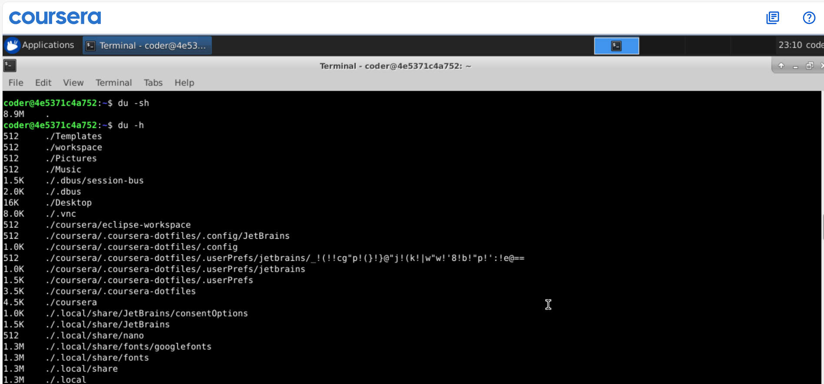
Explanation: As I am already in my home directory, we can use du command with -h option human readable size. Using -s option will show concise info adding all usage. If I am in any other directory I can add ~ at the end of the command.

